Record No: 0670
REGINALD MALCOLM JOHN BELLINGHAM SOMERVILLE (Regi)
of Clermont, Hoey’s Bridge, Kenya; Ruwenzori, Delgany, Co Wicklow and, subsequently, 83, Ailesbury Road, Dublin.

5th son of Bellingham Arthur Somerville (0631) and Margaret Hall Clinch (0632).

Birth: 14 Feb 1897, Clermont, Rathnew, Co Wicklow
Bapt: 18 Aug 1904, St Audoen’s Church, Dublin
Marriage 1: 31 July 1928, St Patrick’s Church, Greystones, Co Wicklow to Maude
Gwendolyne Constance Violet (0671), only dau of Capt Arthur E H Moore,
Royal Dublin Fusiliers (0672), by his wife, Bertha Emily, dau of Henry Murray
Campbell
Marriage 2: 16 Apr 1936 at Wicklow Parish Church, Wicklow , to Honor Lucretia Philippa (0673), 2nd
dau of Rev Canon Philip B Johnson (0674) by his wife Elizabeth Charlotte Annie, nee Pope
Death: 22 July 1971 Bd: Christ Church, Delgany, Co Wicklow

Somerville Index

Notes: Served World War 1: Lt. Royal Warwickshire Regiment 1915-1918
3rd (Special Reserve) Batallion (?)
Fort Purbrook 1915
Parkhurst 1916
France & Belgium 1917 - 1918
(Vimy Ridge & Paaschendael)
Italy 1918

Farming in Kenya with Gunners’ Venture:
Nanyuki 1920
Chania Bridge 1923

Coffee Farming in Kenya Clermont, Hoey’s Bridge
1924 – 1945

Following a long illness from Blackwater Fever in 1934, from which he maintained he only recovered through the ministration of a drunken Irish doctor, he, Maudie and Juanita, accompanied by the redoubtable nanny, Miss Clague, sailed for recuperation and leave in Europe in March 1935. Maudie, who had a sore throat on boarding the SSMadura in Mombasa, immediately developed what was believed to be meningitis and died suddenly two days out and was buried at sea ( see entry at (0671)). Regi, under pressure from his mother, didn’t return to Kenya for many years, but retained the farm until 1945.
Following his marriage to Honor (0673), Regi built Ruwenzori on an elevated site with a panoramic view to remind him of the open spaces of Kenya and started market gardening until war broke out in 1939 when he volunteered and joined the Royal Welch Fusiliers.

Served World War 11: Lt Royal Welch Fusiliers 1939 – 1941
( C Company 1/11 Batallion)
War Work with Sentinel Wagon Works
Shrewsbury 1941 – 1945

By 1941, although only 44, he was deemed ‘too old’ for the Army, so was demobbed (?) and spent the remainder of the war making Bren Gun carriers at Sentinel. He and the family lived throughout the war at Onslow Hall (see entry at (0673)) where Honor was matron at St Georges School. Regi was stationed when in the RWF in several places nearby.

After the war, Regi and the family returned to Ireland, lived initially at Clermont while Ruwenzori was tenanted, and started the market garden again. He continued with this, and running the property at Clermont for his mother and, after her death in 1949, for his brother Bunt. In 1953, he retired to Dublin.

Following Bunt’s death in 1951, Regi, with Cecil (0675) and Tetty (0680), spent much time closing gaps in the Somerville family genealogical information which had been assembled in the Somerville Records which had been given to him. He was encouraged by his sisters, especially Tetty, to establish his claim to the Somerville of Dublin Baronetcy which had been dormant since the death of his cousin, the 2nd Lord Athlumney (0638), in 1929. He and Tetty worked on this with the help of Walter Verco, Chester Herald, Sir Austin Strutt, Registrar of the Baronetage, and Sir Arthur Bellew, then Garter King of Arms. Substantial progress was made between 1955 and 1966, but Regi eventually lost heart and got ill.

As a boy, Regi played in the endless hockey games that the Clermont regime allowed. He adored his father and picked up a certain manual dexterity and interest in photography from him. In his youth, he was a keen fisherman and shot. When Bertie Truell lived at Clonmannon, he spent much of his young life shooting and wild fowling there. Always interested in‘growing things’, in later years, he kept a wonderful town garden in Ailesbury Road, full of colour and scent. His great love was his greenhouse and, particularly, the propagation and growth of cacti.

Regi was intensely reserved, as were, but to a lesser extent, his brothers, Bunt(0660) and Jim(0663): he found it difficult to communicate with outsiders and led a lonely life. The extraordinary way in which they were brought up may have been responsible. While Bunt and Jim did go to primary schools for short periods, the whole family were educated privately by Governesses and Tutors, the Misses Attwood, Shillaker, Tedder and Mr Burks among others. Regi lacked the gravitas of Bunt, the angular curiosity of Jim, and, although he had a quiet, but mischievous sense of humour, he hadn’t the outgoing spontaneity of Pat(0667). Like his father, he was particularly good at carpentry, and generally managed to put right all things that stopped working: eg bells, lights, taps, clocks etc While Pat overcame the disadvantages of their closeted childhood, having a period of peace time training before the traumas of WW1, Regi went straight from the schoolroom and the protected environment of Clermont to the Army at war and was in the trenches before he was twenty. When he did eventually find a life of his own in Kenya, he lost his wife within a few years of marriage. At home, except when useful, he was sorely patronized by his siblings; he became known as, and was referred to as, ‘poor Regi’. Honor suffered similarly; far from being congratulated on the birth of her son, she used to record the incident when she was shut up in the linen room at Clermont by one of Regi’s sisters and sisters in law as they were all jealous that she, Regi’s second wife, had produced the only ‘Somerville’ boy. But, like Regi, Honor was practical and helpful when called upon, and, unlike Regi, she was a manager. Manon (0683) feels Regi suffered throughout his adult life from a silent depression brought on by the horrors of WW1, the disappointment of the Kenya farming venture after Blackwater Fever, the death of Maudie, the refusal of his mother to allow a return to Kenya and the financial difficulties following his mother’s death: Bill’s(0682) memory of his father is the way in which he constantly stood in front of a window staring into space as if wondering what might have been.

WBRBS – from personal knowledge and conversations with Regi and Honor

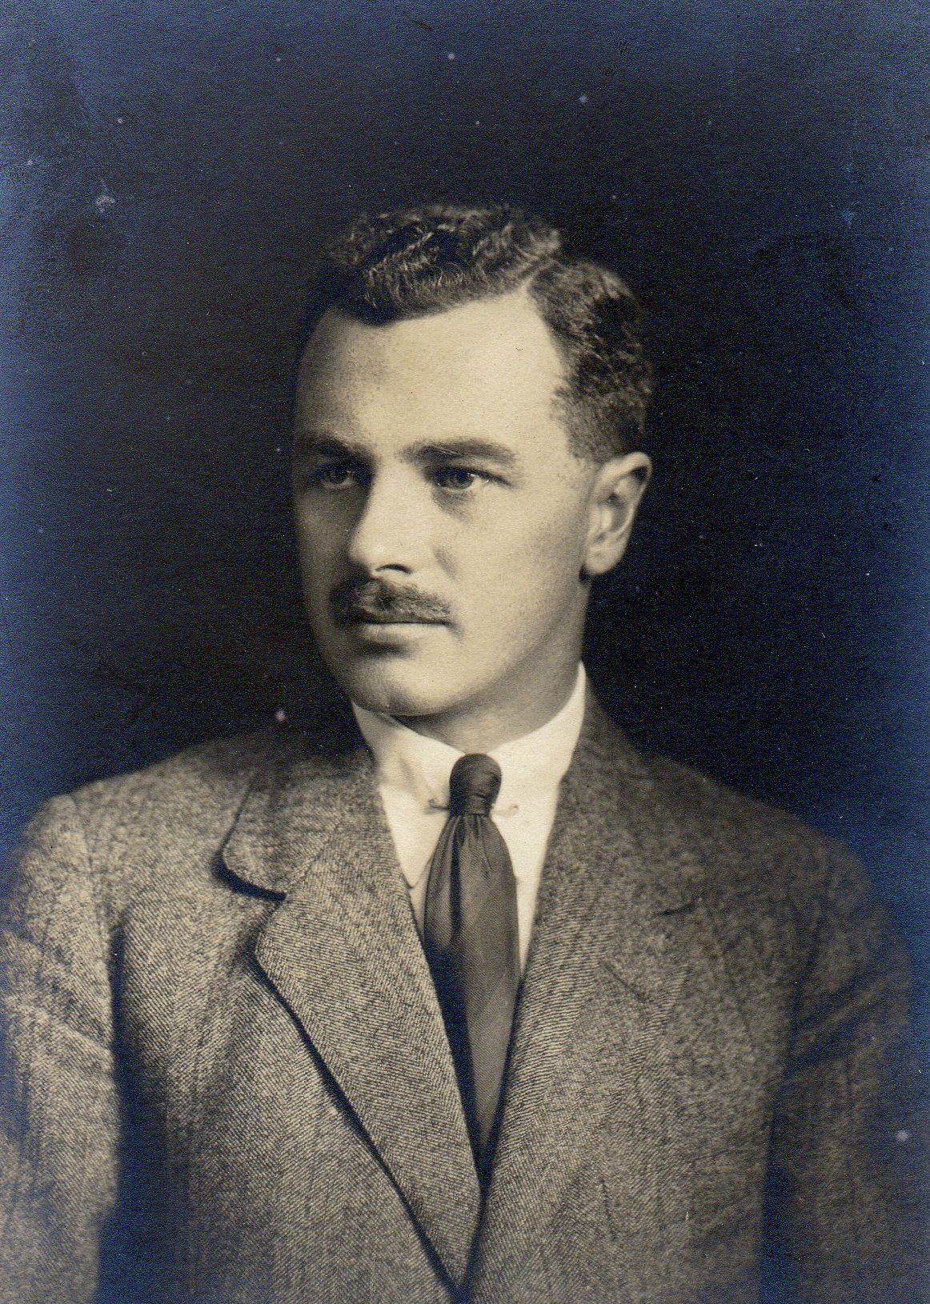

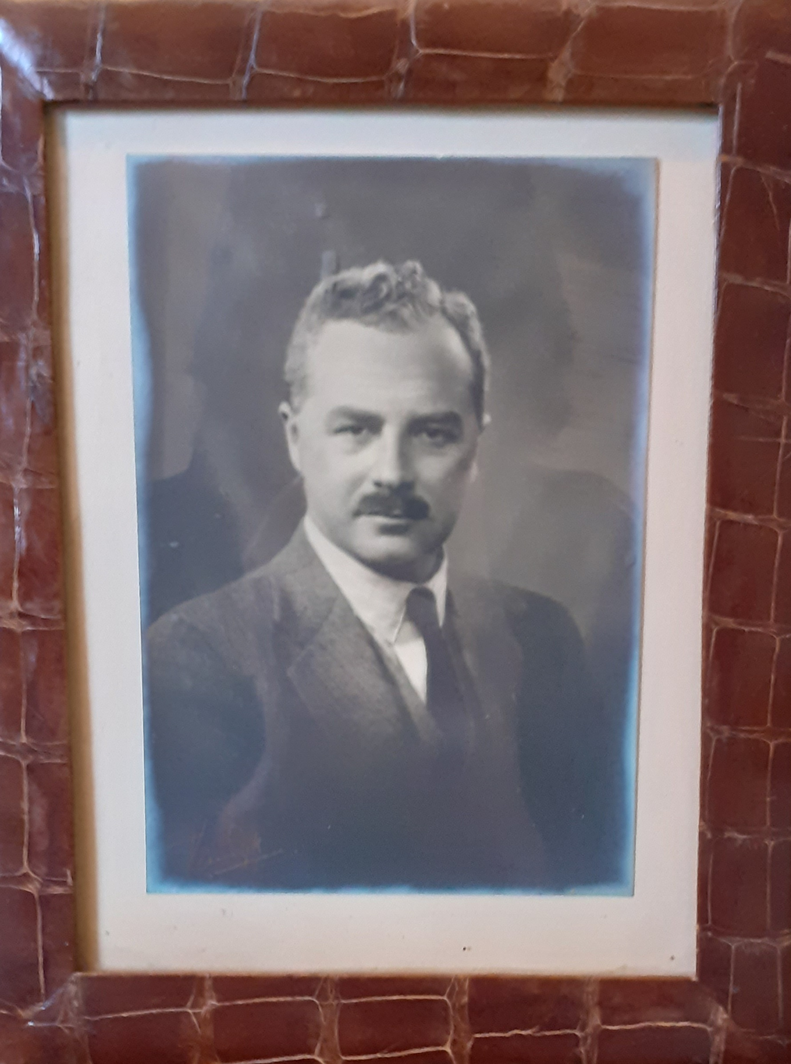

Regi about 1936

Letter from Margaret Hall Somerville to Merlie Truell written from Regi’s home (called Clermont) in Kenya.

CLERMONT
Hoey’s Bridge
Trans Nzoia
Kenya Colony
Saturday
12 Dec 1925
My dearest de Merlie,

I am only sending a short letter to tell you we are quite well. I am having a delightful time here – life here is so free and everything is so interesting – the days seem to fly by. We are always busy but seem to get very little accomplished – there is such a vast amount to be done. The natives are so slow & lazy and it is most difficult to get enough of them – they are too always wanting [illeg] [illeg] and their wages revised – people say that before long there will have to be a great deal more machinery used out here it is so difficult to get labourers + of course oxen are very slow but unfortunately they have to be used as horses will not live here.

It is about impossible to get more than one acre of land ploughed in the day + that takes 16 oxen – 3 boys to drive & guide and a master to lead – so you can tell the time it takes to do things & the noise they make shouting and roaring one would really think there was something exciting happening.

This morning Uncle Regi & I went to Kitale on business – it is a really nice little place which has grown so quickly too – a year ago there was very little [illeg] and a few huts – now they have some quite nice little houses with verandahs + such pretty gardens full of flowers, fruit and vegetables - the strawberries are in blossom. On our way back we called to see some friends of Uncle Regis – a Mr and Mrs Roberts – they are young + quite nice. They have two little girls aged 3¹/₂ years & 7 weeks. They have the sweetest little house with a verandah covered with creepers - & a lovely view. I shall describe all these places to you when we meet.

There is lots of game around here – this morning just after breakfast a buck passed very near the house – constantly we see them. I hear there are lots of hyenas - & zebras – but I have not seen them anywhere. I am told too that an odd lion & leopard + elephant pass by. I hope they will stay away during my visit. There are most wonderful wild flowers + such a variety – they grow in such out of the way places. I never go in the long grass to look for them, I have never seen any reptiles but I am afraid of them & [illeg] too. The weather here changes so quickly, it may be very hot- when suddenly a strong wind may get up & heavy rain comes over – often thunder - & it gets quite chilly but as a rule it is hot from about 10 till 4 o/c – at 6 o/c one is very glad of a fire and the mornings are cold too. We have our breakfast at 7.30, cup of tea at 10.30 – lunch 12.30 – tea 4 o/c – dinner 7 o/c & I go to bed about 9 to 9.30 o/c. The day passes so quickly although always busy so little seems to be done – there is such a lot of work before us – it will take a long time to get the place in order. But it is most interesting - we both love the work and the place.

I am sure you are all busy preparing for Xmas and the holidays. I hope you will have a very nice time & good weather – not too cold – it is difficult here to believe we are near Xmas it is so warm. Please give my best love to all & keep lots to yourself- [illeg illeg] to mother,
Forever always your loving old
Grannie
P.S. Remember me to Grandpapa.

Additional Note by David Gilmour:
Hoey's Bridge was a small farm market town in Kenya’s Rift Valley, named after Arthur Cecil Hoey who settled in the area and built the bridge across the Nzoia River. Today the town is known as Moi's Bridge, after Daniel arap Moi who ruled Kenya from 1978 until 2002.

Passenger shipping records:
2 May 1931: Port of arrival, Southampton. Boat: Tanganjika
Reg M Somerville, aged 34, farmer,
Maude Somerville, aged 30, Mrs
Embarkation: Mombasa
Country of Residence: Kenya Colony
Address in the UK: Ireland, Clermont, Rathnew, Co Wicklow

5 Apr 1935: Return from Kenya, arrival at London. Boat: Madura.
Regi gives his profession as a planter, with him is Juanita, aged 2¹/₂.
Maude died of meningitis on 11 Mar 1935 on the same voyage.

